### Operations and Maintenance Service About SML Energy

Founded in 2017, SML Energy was built on a simple yet powerful mission: to drive a cleaner, more sustainable future. With a steadfast belief that renewable energy can meet the world’s growing energy demands, we specialize in delivering exceptional operations and maintenance services for solar installations.

### Our Story

The journey of SML Energy began with a vision to empower industries to fully harness the potential of solar energy. As the demand for solar solutions surged, we noticed a recurring challenge: businesses were struggling to maintain their solar panels, leading to reduced efficiency and energy output.

Recognizing this gap, we stepped in to provide expert solutions that ensure solar panels remain clean, optimized, and performing at their best. By enhancing the reliability and efficiency of solar installations, we enable businesses to maximize their energy investments while contributing to a greener planet.

### Our Commitment

At SML Energy, we are dedicated to empowering sustainable growth for industries through innovative maintenance solutions and an unwavering focus on quality. Together, we’re making renewable energy more accessible, efficient, and impactful.

**"Without proper O&M services, 30% to 40% of electricity generation potential can be lost, drastically lowering system performance." (Home Page)**

**Keep your solar panels running at optimal efficiency with SML Energy's reliable and affordable solar O&M service. Trust us to handle all your maintenance needs and ensure maximum energy savings for your home or business.**

# Solar Panel Operation & Maintenance Services

SML Energy specializes in providing complete O&M solutions for solar panels, ensuring consistent optimal performance of your solar power systems over time. By enhancing the efficiency, longevity, and reliability of your solar installations, we aim to help you cut down on energy expenses and reduce your environmental impact.

***Why Choose SML Energy for O&M Services?***

Solar panels are a long-term investment, and regular maintenance is essential to ensure that your system operates at peak performance. SML Energy O&M services provide the following benefits:

* **Enhanced System Efficiency:** Regular maintenance and monitoring ensure that your solar panels are generating energy efficiently and without interruptions.
* **Extended System Lifespan:** Preventive maintenance helps avoid major issues, thus extending the overall lifespan of your solar system.
* **Cost Savings:** Early identification of faults reduces the risk of costly repairs and system downtime.
* **Improved Reliability:** Routine checks and cleaning prevent issues like dirt buildup or shading, which can reduce energy production.
* **Compliance & Warranty Protection:** Our O&M services help ensure that your system meets all safety regulations and warranty requirements.
* **Customized Solutions:** We tailor our O&M service to meet the specific needs of each solar power plant, ensuring optimal performance and efficiency.

***SML Energy’s O&M Services Include:***

## Routine Inspection and Testing:

* + Visual inspection of solar panels for physical damage, debris, or shading issues.
  + Electrical system testing, including the inverter and wiring, to ensure everything is functioning properly.
  + Monitoring system performance through advanced tools and technology to identify energy generation trends.

## Cleaning and Panel Maintenance:

* + Regular cleaning of solar panels to remove dust, dirt, and debris that can block sunlight and reduce energy output.
  + Cleaning of inverters and other electrical components to maintain efficiency.
  + Checking for shading issues from trees, buildings, or other obstructions that can reduce system performance.

## Repairs and Troubleshooting:

* + Fast response to any system faults or malfunctions.
  + Replacement of faulty components such as inverters, panels, or wiring.
  + Troubleshooting and rectifying issues that cause power loss, ensuring minimal downtime.

## Performance Monitoring:

* + Continuous monitoring of your solar system’s performance using real-time data analytics.
  + Remote monitoring for quicker identification and resolution of issues.
  + Regular reporting and analysis of energy production to ensure optimal system performance.

## Preventive Maintenance:

* + Preventive measures to detect and address potential issues before they become costly problems.
  + Annual or semi-annual checks to ensure optimal performance throughout the year.

## Upgrades and System Optimization:

* + Recommendations for system upgrades to improve efficiency and adapt to new technologies.
  + Consultation on battery storage options or hybrid solutions for enhanced energy independence.

## 24/7 Emergency Support:

* + Access to a dedicated team of experts for urgent maintenance or troubleshooting.
  + Fast and efficient service to minimize downtime and maximize energy generation.
  + Rapid response to emergency situations, including equipment failures and natural disasters.

***O&M Approach***

We take a proactive approach to managing the corrective maintenance of solar energy systems. By using cutting-edge technology and expert technicians, we ensure that your system runs smoothly and remains compliant with all safety and warranty standards.

Our O&M approach is continuously evolving, incorporating new technologies, best practices and lessons learned to ensure optimal performance and efficiency for long term.

We ensure that our O&M activities comply with relevant regulations and industry standards minimizing the risk of fines or penalties. **(Infographics Diagram)**

#### Why Trust SML Energy for Your Solar O&M Needs?

* **Expertise:** Our team of certified technicians has years of experience in solar O&M services, ensuring top-quality work and reliable results.
* **Customized Solutions:** We understand that every solar system is unique, which is why we offer personalized O&M plans to suit your specific needs.
* **Quality Assurance:** We only use the best tools and equipment to perform maintenance and repairs, ensuring that your solar panels continue to operate at peak performance.
* **Transparent Reporting:** We provide detailed reports on your system's performance, maintenance activities, and any issues discovered, giving you full visibility

## Client Overview:

A leading renewable energy developer operating a 25 MW solar farm in a semi-arid region sought our expertise to enhance operational efficiency and reduce downtime. The client faced challenges with frequent dust accumulation, inverter breakdowns, and suboptimal energy generation.

# Challenges:

## Dust Accumulation:

The plant was located in a high-dust area, reducing solar panel efficiency by up to 18%.

## Inverter Failures:

The aging inverters caused frequent disruptions, leading to increased downtime.

## Monitoring Limitations:

The existing monitoring system lacked real-time data, delaying fault detection and response.

# Solution Provided:

## Proactive Cleaning and Maintenance:

* + Introduced a bi-weekly cleaning schedule using automated cleaning systems to minimize dust impact.
  + Scheduled preventive maintenance for all critical components, including inverters and transformers.

## Advanced Monitoring Systems:

* + Deployed IoT-enabled SCADA systems for real-time performance tracking and anomaly detection.
  + Installed weather sensors to optimize energy generation based on environmental conditions.

## Thermal Imaging Inspections:

* + Conducted thermal imaging surveys to identify hotspots and potential faults in solar modules.
  + Implemented corrective actions promptly to prevent further damage.

## Inverter Replacement and Optimization:

* + Upgraded faulty inverters with high-efficiency models, reducing breakdowns.
  + Provided training to the client's in-house team for basic troubleshooting.

# Outcomes:

## Increased Energy Yield:

Energy generation improved by 22% within six months due to better panel cleaning and optimized system operations.

## Reduced Downtime:

Downtime decreased by 35%, thanks to proactive maintenance and real-time fault detection.

## Cost Savings:

Maintenance costs dropped by 15% as preventive strategies reduced emergency repairs.

## Sustainability Impact:

The enhanced efficiency led to clean energy annually, powering approximately thousands of homes.

# Client Testimonial:

*"Partnering with SML Energy has transformed our solar plant’s operations. Their proactive approach and technological expertise have not only maximized our energy yield but also reduced our overall maintenance costs. We highly recommend their O&M services."*

— **Operations Manager, Toray Plant**

# Why This Matters:

This case highlights how a well-structured O&M service can significantly improve the efficiency and profitability of solar energy projects, aligning with clients' sustainability goals.

## Interested in similar results for your solar project?

Contact Us Today to learn how our tailored O&M services can help you maximize performance and reduce operational risks.

You can adapt this structure to match specific project details, showcasing the unique value you provide to your clients.

Here’s a structured case study for publishing on your website regarding Operation & Maintenance (O&M) services for solar power plants. This includes real-world examples to demonstrate effectiveness and industry standards.

# Case Study: Enhancing Solar Asset Performance with Proactive O&M

***Client Overview***

A utility-scale solar farm with a capacity of 1 MW, operational for over five years, was experiencing challenges in maintaining optimal performance. Issues included frequent inverter failures, suboptimal energy output, and increased downtime due to reactive maintenance.

#### Challenges

1. **Inverter Failures:** Regular breakdowns caused energy losses and repair delays.
2. **Decreased Performance Ratio (PR):** Dust accumulation and module degradation affected efficiency.
3. **Unpredictable Maintenance Costs:** Reactive repairs led to higher operational costs.
4. **Data Gaps:** Lack of detailed performance monitoring hindered troubleshooting.

***O&M Strategy Implemented***

## Proactive Maintenance:

* + A thorough Failure Mode and Effects Analysis (FMEA) was conducted to identify critical components prone to failure, such as inverters and trackers.
  + Condition-based maintenance was introduced to minimize downtime.

## Monitoring and Analytics:

* + Advanced monitoring tools were deployed to track key performance indicators (KPIs) like PR and energy yield in real time.
  + Predictive analytics flagged potential equipment failures before they occurred.

## Cleaning and Efficiency Boost:

Manual cleaning systems have been introduced as a more effective solution than robotic systems, offering better panel cleanliness and improving energy yield.

## Spare Parts Management:

* + A strategic stockpile of essential components such as inverters and fuses was maintained to reduce repair lead times.

## Training and Skill Development:

* + On-site personnel were trained on the latest solar maintenance techniques, ensuring quick response and fewer errors.

#### Results

1. **Performance Improvement:** PR improved by 10%, increasing annual energy output by 12%.
2. **Reduced Downtime:** Inverter failure rates dropped by 30% due to preventive measures.
3. **Cost Optimization:** Proactive maintenance reduced annual O&M costs by 15%.
4. **Sustainability Impact:** Enhanced energy output avoided an additional 1,000 tons of CO₂ emissions annually.

***Conclusion***

This case demonstrates that a structured, technology-driven O&M strategy is critical for maximizing solar plant efficiency, reducing costs, and ensuring long-term sustainability. This case study demonstrates the importance of proactive O&M in ensuring optimal solar asset performance.

For more insights into similar projects or to explore our O&M services, contact us today.

Transformer Maintenance Work Inverter Maintenance work UPS Maintenance Work

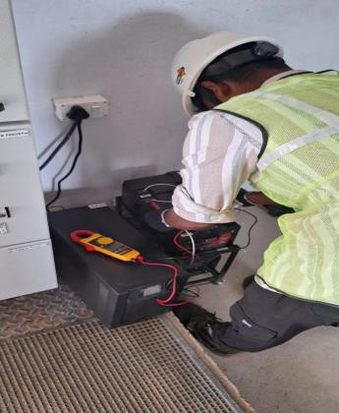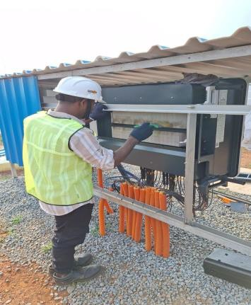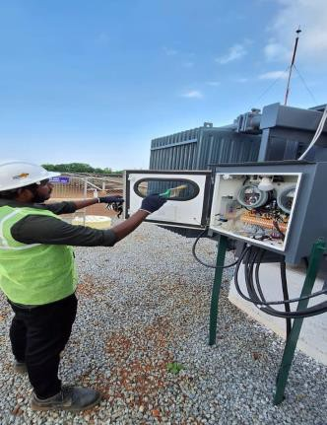

WMS Maintenance Work LOTO System Work LOTO System Work

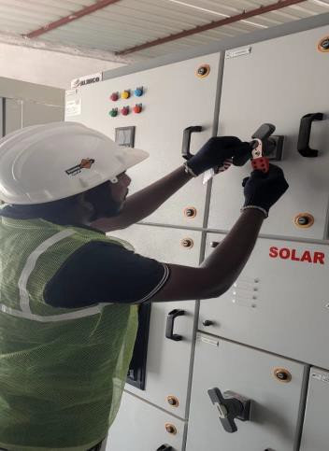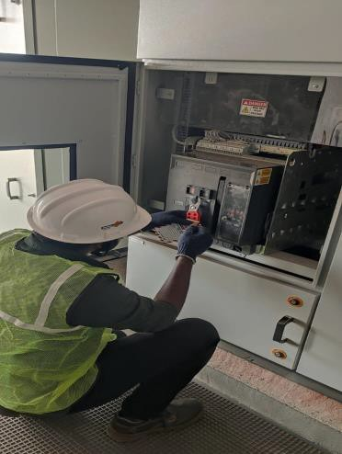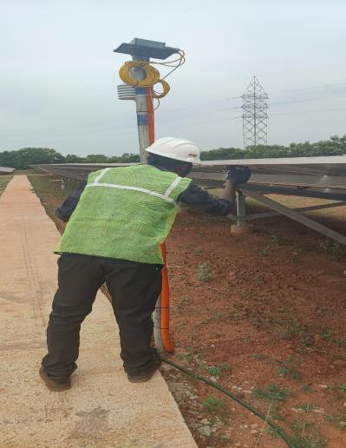

Panel Discharge Work Panel Discharge Work Panel Discharge Work

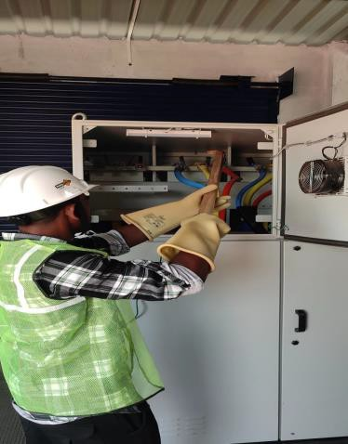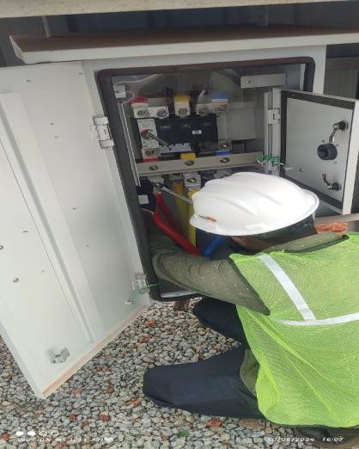

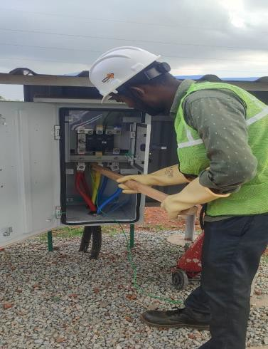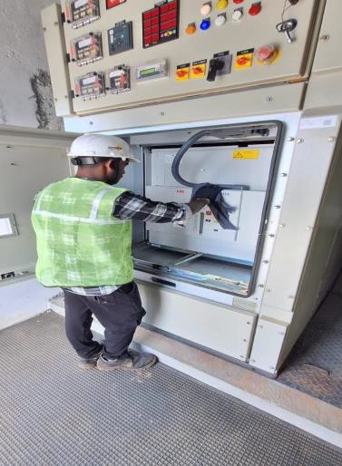

VCB Maintenance work LT Panel Maintenance Isolator Maintenance

Module Cleaning Solar Module Maintenance Solar Ground Mounted

